

AMERICAN INTERNATIONAL UNIVERSITY–BANGLADESH (AIUB)

Faculty of Science and Technology

Dept. of Computer Science

COURSE: SOFTWARE ENGINEERING

Fall 2025-2026

Section: [V]

Group No: [03]

Software Requirement Specification [SRS] Document On

Project Name [TravelBuddy : Local Travel Companion]

Supervised By: ZINNIYA TAFFANNUM PRITEE

Submitted By

Name |  | ID
1. | SHANTUNU BARUA | 23-53712-3
2. | M.SAKIB SADMAN ARIAN | 23-54986-3
3. | MD. ARAFAT RAHMAN SAMIR | 23-55488-3
4. | RAYEAN SADIK | 23-55508-3

Table of Contents

1. INTRODUCTION 3
1.1 Background Description 3
1.2 Target Group of Users 3
2. SCOPES & FEATURES 5
2.1 Scope 1 : Trip Planning 5
2.2 Scope 2 : Budget-Friendly Search 5
2.3 Scope 3 : Safety Features 5
2.4 Scope 4 : Multilingual & Localized Guidance 5
2.5 Scope 5 : Service Provider Integration 5
2.6 Scope 6 : Authority Functions 5
3. USE CASE DIAGRAM 6
3.1 Description 6
3.2 Diagram 7
4. USER STORY TABLE 8
5. REQUIREMENT TRACEABILITY MATRIX 9
5.1 Functional Requirements 9
5.2 Non-Functional Requirements 9

INTRODUCTION

Background Description
Tourists often face problems when planning trips, such as finding affordable hotels, restaurants and transportation within their budget. They also struggle to decide which places to visit first and how to ensure safety while traveling in unknown places. Most travel apps focus on expensive options and do not provide budget-friendly recommendations or complete travel guidance.
TravelBuddy: Local Travel Companion is designed to provide a smart and user friendly tourists plan their trips, find safe and affordable options and have a well organized travel experience.

Target Group of Users
- Local Tourists
- Affordable and budget friendly travel options.
- Closest attractions, hotels and restaurants.
- Safe and easy trip planning.
- International Tourists
- Guidance in an unfamiliar country.
- Trusted and reliable hotels, restaurants, transport and local help.
- Simple, easy and language friendly support.
- Solo Travelers (Students/Females)
- Safe routes, emergency help and reliable transport.
- Budget friendly reccommodations.
- Quick and easy travel guidance.
- Group Travelers (Families/Friends)
- Well Organized multi day trip plans.
- Comfortable and private hotels-restaurants.
- Safe and easy booking for group transport and guides.
- Business Travelers
- Fast access to hotels and transport.
- Time saving and efficient travel plans.
- Safe and convenient options near their meetings.

- Adventure Travelers / Content Creators
- Hidden or less popular destinations.
- Flexible plans with budget.
- Local tips, safety alerts and good routes.
- Local Tourism Service Providers
- Small hotels, restaurants, cafes and guest houses.
- Vehicle rental services.
- Travel agencies and tour operators offering tours and packages.
- Local Authorities & Tourism Boards
- Promote safe and responsible travel.
- Share updated safety alerts and travel information.
- Provide safety in new or seasonal tourist attractions.

SCOPES & FEATURES

Scope 1 : Trip Planning
- Generate smart travel plans.
- Show nearby attraction recommendations.
- Suggest the best routes.

Scope 2 : Budget-Friendly Search
- Filter hotels, restaurants and transport by budget.
- Show ratings, distance and pricing.
- Show affordable and nearby suggestions.

Scope 3 : Safety Features
- Real-time safety alerts.
- Safe route suggestions.
- Female-friendly and safe transport indicators.

Scope 4 : Multilingual & Localized Guidance
- Provide multi-language support for international users
- Show verified local recommendations for hotels, food, and transport
- Offer culture-aware tips for safe and respectful travel

Scope 5 : Service Provider Integration
- Listings for small hotels, cafes, rentals, and local tour operators
- Promotional space for verified local businesses.
- Admin and Authority verification.

Scope 6 : Authority Functions
- Publish safety alerts and updates.
- Approve and verify service providers.
- Monitor destination safety reports.

USE CASE DIAGRAM

Description
The system allows Tourists, Service Providers, and Authorities to Register/Login with email or phone number, where the Server automatically verifies accounts. Tourists can Manage Profile to update personal information and preferences, then Search Destinations by applying filters for distance, rating, price and with additional features to View Nearby Attractions. Moreover, AI View Recommendations based on preferences. Users can Generate Trip Plan to create optimized single-day or multi-day trips, then Search/Booking Services for hotels, transportation and restaurants which includes Process Payment that connects to Validate Booking Payment handled by Server. Tourists access Get Safety Alerts for real-time warnings and can trigger Emergency Helpline to send live location to authorities, while they can also Rate and Review Services after trips. Service Providers Verify Business Documents during registration, then Update Service Details and Manage Bookings by viewing requests, Accept/Reject Bookings based on availability and also create Special Offers/Discounts. Admin performs Verify Accounts by checking documents, uses Manage Accounts, can Ban/Suspend Accounts for violations, Maintain System for performance. Authorities Provide/Publish Safety Alerts to inform tourists, Approve New Destinations for official recognition, Verify Service Provider Legitimacy for trust badges, and Monitor Reports/Complaints to ensure tourist safety and service quality across the platform.

Diagram

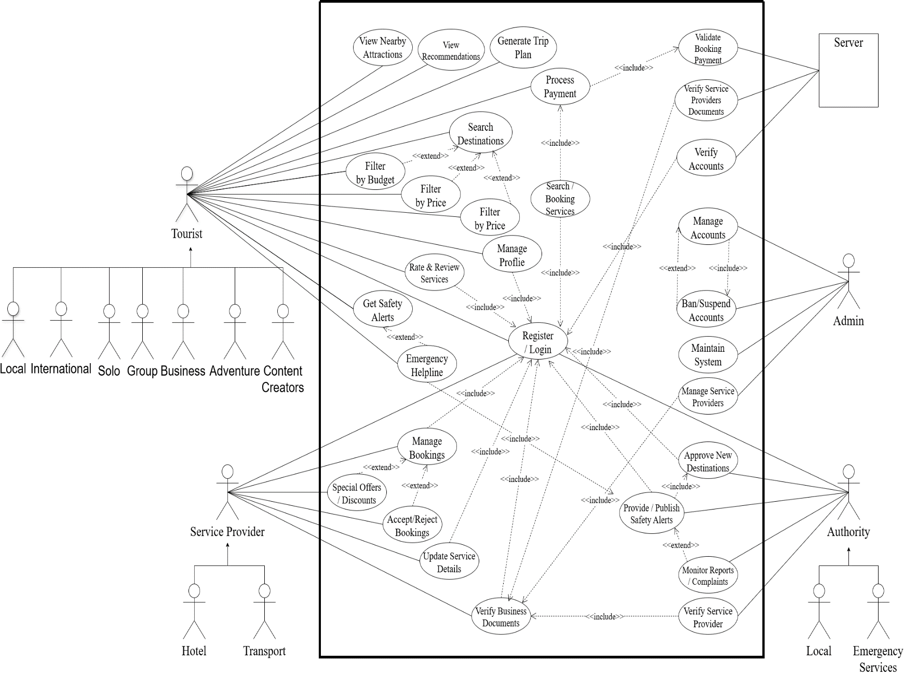

USER STORY TABLE
As a/An | I want to | So that | Acceptance Criteria
Local Tourist | Find nearby attractions, hotels & restaurants | I can plan affordable trips | System shows distance, price & rating filters
International Tourist | Use a multilingual and easy interface | I can understand everything easily | English/Bangla switch, translated labels
Solo Traveler  (Students/Females) | Find cheap stays and Get safe routes guidance | I can travel within budget with safely | Low-cost options and safe planning tips shown
Group Traveler (Family/Friends) | Plan or book group friendly trips | We can travel together smoothly | Group rooms/vehicles shown with capacity
Business Traveler | Quickly find premium hotels & transport | I can save time during work trips | Shows verified, fast-booking services
Adventure Traveler | Discover hidden/adventure spots | I can explore safely | Shows difficulty level & safety warnings
Content Creator | Find unique photo-worthy places | I can create original content | Shows hidden spots and best photo times
Service Provider | Register and update my business | Tourists can find my services | Registration with valid documents and admin approval
Tourism Authority | Publish alerts and provide safety | Tourists stay informed and emergencies are handled | Alert panel with live location
Admin | Verify users/providers & manage system | Platform stays secure | Admin can approve, block, or monitor

REQUIREMENT TRACEABILITY MATRIX

Functional Requirements
  - User Registration & Login
The system shall allow tourists, service providers and authorities to register and log in securely.
  - Trip Planning
The system shall generate personalized itineraries based on location, time, and budget.
  - Search & Filter
The system shall allow searching attractions, hotels, restaurants, and transport with filters by budget, rating or safety.
  - Nearby Recommendations
The system shall show nearby places using GPS location.
  - Language Support
The system shall support English and Bangla language switching.
  - Provider Registration
The system shall allow service providers to submit business details for verification.
  - Authority Alerts
Authorities shall publish, edit, and remove safety alerts.
  - Admin Management
Admins shall verify providers and manage user accounts.

Non-Functional Requirements
- Performance
Search and trips plan results shall load within 3 seconds.
- Availability
The system shall maintain 99% uptime.
- Usability
Core tasks shall be completed in under 5 steps.
- Security
All data shall be encrypted.
- Compatibility
The system shall work on Android, iOS and web browsers.
- Localization
UI shall be available in English and Bangla.
- Reliability
The system shall not lose saved data.
- Privacy
User data shall not be shared without consent.


